NEPAL COLLEGE OF INFORMATION TECHNOLOGY

Level: Bachelor Year: 2010
Programme: BE Full Marks: 60
Course: Applied Mechanics Time: 2 hrs

Attempt all the questions.

- a. Three forces act on the bracket. Determine the magnitude and direction θ of F₁ so that the resultant force is directed along the positive x’ axis and has a magnitude of 800 N. [7]
.
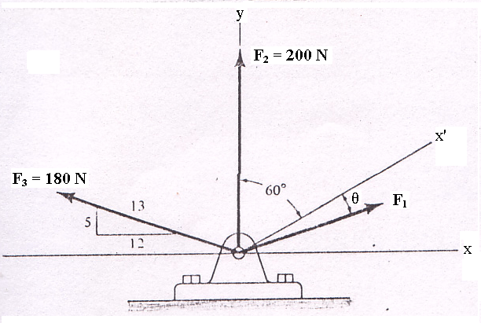

b. Determine the direction θ of the force F = 40 N so that it produces (a) the maximum moment about point A and (b) the minimum moment about point A. [8]

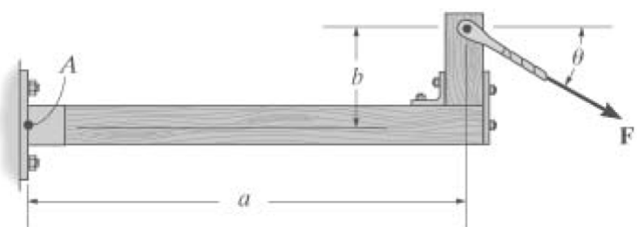

2. a. What do you mean by free body diagram? Describe with sketch. [5]
b. A 12 kg box is suspended as shown. Determine the applied force P which will induce cable tensions T_{AB} = 70 N, T_{AC} = 45 N, and T_{AD} = 0. [10]

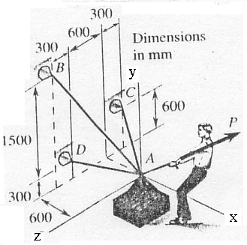
3. a. Locate the centroid of any circle by methode of double integration. [7]

b. Determine the stretch in each spring for equilibrium of the block of mass M. The springs are shown in the equilibrium position. Where Mass (M) = 2 Kg, a = 3 m, b = 3m, c = 4 m, K_{AB} = 30 N/m, K_{AC} = 20 N/m , K_{AD} =40 N/m. [8]

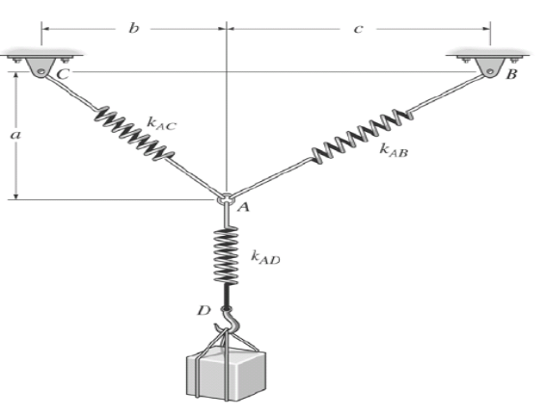
- a. What should be the value of angle so that motion of the 90 N block impends down the plane? The coefficient of friction for all surfaces is 1/3. [7]
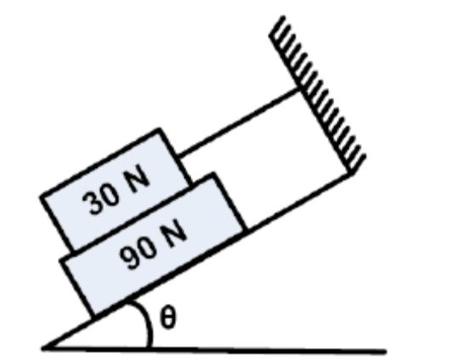

4. b. Determine by direct integration the centroid of the shaded area. [8]

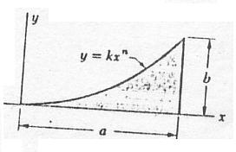

OR
Determine the centroid of the shaded area.
